**RISC Scan Operating Procedure**

**Set-up:**

* Have the subject fill out the MRI safety screening form in the control room—**ensure they are completely de-metaled**
* Provide the subject with ear plugs—the smaller ear plugs are pink-colored and located next to the cabinets closest to the window in the scanner room
* **Make sure you are de-metaled before entering the scan room** 
  + *If setting up alone, the pulse oximeter and respiratory belt are on the hooks behind the cabinets left of the scanner as you enter the room*
* Ask the subject to sit up on the MRI bed using the stool—be sure to check their ear plugs before you have them lie down
* Have the subject lie down and move their head up into the head coil
* Wrap the **respiratory belt** around their chest/abdomen and secure the Velcro
* Place the pulse oximeter on their **non-dominant index finger**, with the sensor under their finger
  + *Secure with medical tape wrapped around their index and middle finger*
* Wrap the emergency squeeze around the subject’s dominant hand and instruct subject on how to use it
* Place button box in subject’s **dominant** hand
* Place padding on either side of the subject’s head and slide the plastic mask over his/her face
* Use the light bulb button on the scan machine to landmark the laser at the brow ridge—press the button again to confirm the landmark
* Send the subject in using the I I button
* **Set up BIOPAC-physio computer** while tech is helping the subject into the scanner
  + Sign on to the Biopac username password: AcqKnowledge
  + Open Acknowledge 4.2 (on desktop)
  + Start new recording
    - Recent graph template
      * Belt B (usually the first option)
  + Click on MP150 tab on top of screen
    - Triggering🡪 make sure it is OFF ONLY FOR TEST
  + Click “**Start”** in the upper left corner to test the recording. Right-click the green recording(respiration) and select **“Autoscale waveforms”**
  + Hit “**Stop”** when you are satisfied
    - Go to MP150 🡪 Setup triggering and Turn triggering on, select “**CH8**” from the drop-down list
  + Click on MP150 tab on top of screen
    - Acquisition
      * Change seconds to minutes (11)
      * File 🡪 Click File and save as “Subjectinitials.date.0001” under **PhysioRecordings\ETPB\Ballard-RISC**
      * Set heart monitor interval to 500 (should be default)
      * Hit close, new screen pops up check the incrementing minutes button
  + Hit start right before resting state begins

Not relevant until resting state scan🡪

* + - Window will pop up saying “wait for triggering” means that it will begin once the scan does
  + To view all waveforms on top row of graph, R click and hit autoscale
* On the scan computer, select **Patient**(located at Top Toolbar)🡪 **Scheduler**🡪Click subject’s name🡪Double-click “**MRI Limited**”
  + Enter Weight (on Order sheet), Study(**UserProtocols/RISC**), (supposed to be UserProtocols/ETPB) Position(**Head first Supine**) and hit **Exam**
* Place labels from order sheet on scan log book and MRI safety screening form

**MAKE SURE YOU CLEAR THE SHIMS**

**Scan:**

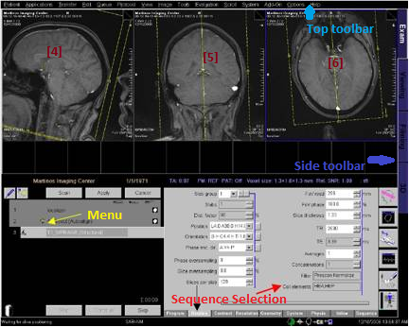

*Image adapted from Martinos Imaging Center website.*

*Periodically speak with patients asking them how they are doing and informing them of the time left in the scan—especially before longer scans*

* The session should be in **Exam** View on **Side Toolbar**
  + *If not, the tab is located on top right of side bar in black and purple*
* Hit Ctrl+Esc, select **SetSHIM.exe** and **CLEAR** all the shimming values before starting the first scan (if already running, press Alt +Tab to bring up the Shim program)
* *Tell patient that first scan (Localizer + B1 Map) will be 1:30 min.*
* Move the **Localizer** sequence **<<** to the menu. Hit **Open**. Hit **Apply** to start the localizing scan
  + *In general, hit apply if you want to scan once; hit scan if you want to scan more than once*
  + *You will need to click “Continue” or “OK” on all the pre-scan dialog boxes*
* Move over **<<** **B1 map** to the menu hit **Open** and then **Apply**
  + *You will need to click “Continue” or “OK” on all the pre-scan dialog boxes*
* Once B1 map has completed, drag head icon next to B1 from menu to left display window and record temperature value[In Volts](called TraRef) from the bottom of the image onto the run sheet
* Move over **<<ANAT_T1 MPRAGE** to the menu, and hit **Open**
* Drag the head icon next to localizer to the left display window ([4]) and check to see that the brain is within the field for the anatomical scan
* Go to **Options**(located at Top Toolbar)**🡪Adjustments🡪Transmitter🡪[Input the value from B1 map at top right text box]🡪 Apply🡪Close**
  + *This will change the transmitter amplitude.*
* *Tell patient that scan will be 7 min.*
* Hit **Apply** and it will start the ANAT_T1 MPRAGE anatomical scan
  + *You will need to click “Continue” or “OK” on all the pre-scan dialog boxes*
* Move over <<**ANAT_NORM_PD** to the menu and hit **Open**
* Right-click “**Copy Parameters**” on ANAT MPRAGE🡪Select **Center of Slice**🡪Hit Ok
* *Tell patient that scan will be ~5 min*.
* Hit **Apply** and it will scan through the proton density scan
* Once you see the head icon next to ANAT MPRAGE, go to **3D** on **Side Toolbar**
  + Go to **Patient** (located at Top Toolbar)**🡪Patient Browser 🡪Local Database**. Drag ANAT MPRAGE [4] to the **3D** viewing window
    - Click “**Yes”** when prompted about loading a new sequence
  + Click on top left button under **Settings**, called “**Parallel Ranges”**
  + Change distance between image to **1.0 mm** (Hit enter after)
  + Hit button at top right, “**Constant Images**” to make slice distance constant
    - *Button should turn from white to grey*
* Adjust the positioning of the slices in the display window to cover the whole brain and skull including cerebellum🡪hit **Start** and the “**Yes”** in the dialog box to save
  + Do the same for the coronal direction🡪 Hit **Start**, hit **Close**, and then **“Yes”** to save
* Go to **Exam🡪**Drag each of the anatomical images that says “MP Range” from **Patient Browser** to the display window (usually [4] [5] and [6] for left, center and right panel, respectively)

**Functional Imaging**

* Move over the entire block of fMRI scans (*see below*).

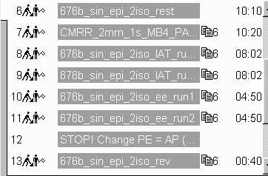

* Open **676b_sin_epi_2iso_rest** to adjust the yellow slice volume so that it encompasses the whole brain.
  + ***Rotate* O *until there is whole brain coverage****—it is okay to leave out a little bit of cerebellum as long as you include the entire cerebral cortex*
* *Tell patient that next scan will be a series of short scans lasting ~5 min.*
* After placing the slice, Go to **Options**(located at Top Toolbar)**🡪Adjustments🡪3D Shim**
* Hit **Load Tune-up**(only first time),**Measure, Calculate, Apply** button in order
* Pull up the **ShimSet** window from the beginning of the scan, and hit **SetShims_3rd**
  + *The Measure-Calculate-Apply-Set(or MCAS) can be done twice, make sure you wait about 30 seconds after you “set” the first time to ensure the shim coefficients in 1st, 2nd, 3rd order are converging*
* Go to **Frequency**, and hit **Go**. You will need to hit **Go** one more time before the frequency value converges, and then hit **Close** (techs said to check the bottom left of the screen and see if it reads “adjustment converged.” If it says this, hit close. If it reads “adjustment not converged,” then hit Go one more time, and then hit close.”
* On the BIOPAC-Physio computer, hit **Start** to begin physio recording. A window saying “Acquisition starting”

*Tell patient to have their eyes closed for the next 10 minutes, trying not to fall asleep during this resting state*

* Hit **Apply** to begin **676b_sin_epi_2iso_rest**.
  + *You will need to click “Continue” or “OK” on all the pre-scan dialog boxes*
* Hit **Stop** on physio recording once rest scan has completed
* Open **<<** **CMRR_2mm_1s_MB4_PA…** (*parameters from first resting state scan should auto-copy*)
  + If parameters do not auto-copy, right-click “**Copy Parameters**” on 676b_sin_epi_2iso_rest🡪Select “**Center of Slice”** and hit OK but **DO NOT HIT APPLY yet**
* On the BIOPAC-Physio computer, hit **Start** to begin physio recording. A window saying “Acquisition starting”

*Tell patient to have their eyes closed for the next 10 minutes, trying not to fall asleep during this resting state*

* Hit **Apply** to begin the second 10 minute resting state, CMRR_2mm_1s_MB4_PA
  + *You will need to click “Continue” or “OK” on all the pre-scan dialog boxes*
  + Physio recording will begin after roughly 20 seconds
* Find the **“Inline Display”** icon near the **Side Toolbar**
  + *This will open a Prog Step window that will show you the EPI images in real-time—Check for distortion and noise (blurriness and patterned artifacts)*
* Hit **Stop** on physio recording once rest scan has completed

**Task Procedures** (*see RISC 7T task instructions document for further guidance)*

For IAT:

* **Start** physio recording.
* Open **<<** **676b_sin_epi_2iso_IAT_run1.**
  + If parameters do not auto-copy, right-click “**Copy Parameters**” on 676b_sin_epi_2iso_rest🡪Select “**Center of Slice”** and hit OK but **DO NOT HIT APPLY yet**
* Hit **Apply** to begin first run of IAT.
* **Stop** physio after scan is complete.
* **Start** physio recording.
* Open **<<** **676b_sin_epi_2iso_IAT_run2.**
  + If parameters do not auto-copy, right-click “**Copy Parameters**” on 676b_sin_epi_2iso_rest🡪Select “**Center of Slice”** and hit OK but **DO NOT HIT APPLY yet**
* Hit **Apply** to begin second run of IAT.
* **Stop** physio after scan is complete.

**For EE**

* **Start** physio recording.
* Open **<<** **676bsin_epi_2iso_ee_run1**.
  + If parameters do not auto-copy, right-click “**Copy Parameters**” on 676b_sin_epi_2iso_rest🡪Select “**Center of Slice”** and hit OK but **DO NOT HIT APPLY yet**
* **Stop** physio after scan is complete.
* **Start** physio recording.
* Open **<<** **676bsin_epi_2iso_ee_run2**.
  + If parameters do not auto-copy, right-click “**Copy Parameters**” on 676b_sin_epi_2iso_rest🡪Select “**Center of Slice”** and hit OK but **DO NOT HIT APPLY yet**
* **Stop** physio after scan is complete.

**For calibration scan:**

* Open **<<** **676b_sin_2iso_rev.**
  + If parameters do not auto-copy, right-click “**Copy Parameters**” on 676b_sin_epi_2iso_rest🡪Select “**Center of Slice”** and hit OK but **DO NOT HIT APPLY yet**
* Double click on the program and under Routine Tab, change the Phase Enc Dir. Click on the […] gray box to the left (this should say right) and rotate 180 degrees. This should change the direction from P>>A or R>>L to A>>P.

**CLEAR SHIMS in ShimSet—very important!**

**MRS sequence voxel (medial Prefrontal Cortex)-** *Place voxel during calibration scan*

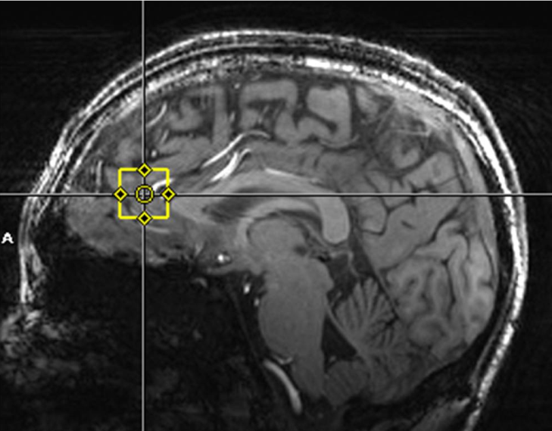

* *Tell patient there will be a series of short scans for a period of ~5 to 10 min.*
* Move over <<**FASTMAP** to the menu and hit **Open**, voxel should now appear
* Hit **Scan** once the voxel is placed in the desired location
  + *You will need to click “Continue” or “OK” on all the pre-scan dialog boxes*
* Hit ctrl +esc 🡪**Windows Explorer D:/LiAn/Software** and go to Li’s **Spectropeek.exe** software by double-clicking the application
* Once FASTMAP has concluded, click on the FASTMAP tab in SpectroPeek and hit **Retrieve Shim values** (located at the top). Then **Apply shim coeffients**(located at the bottom)
  + Hit **Scan** once again for FASTMAP and **Apply shim coeffients** again till the slope of the line for shim values is flattened
* **Cancel** extra FASTMAP and move it to the trash in the lower left
* Move over **<<** **PRESS** to the menu, and hit **Open**
* Right-click already ran FASTMAP and select **“Copy Parameters”** 🡪”**Measurement Parameters”** and hit Ok
* Hit **Scan** for PRESS
* Once PRESS has concluded, click on the PRESS tab in SpectroPeek and hit **Retrieve** (located at the top left). Then **Set Frequency** (located at the top right)
  + *If setting the frequency fails, run PRESS again but hit Scan instead of Apply*
  + *Check the water linewidth on the press software, if it is too high (>15 hz), then you need to do the FASTMAP step again*
* **Cancel** extra PRESS and move it to the trash in the lower left
* Move over **<<** **B1 Profile** to the menu
* Right-click already ran PRESS and select **“Copy Parameters”** 🡪”**Measurement Parameters”** and hit Ok
* Hit **Scan** for B1 Profile
  + *You will need to click “Continue” or “OK” on all the pre-scan dialog boxes*
* Click on the B1 profile tab in SpectroPeek and hit **Retrieve** (located at the top left)
* On opened B1 Profile, Go to **Contrast** (on very bottom of Sequence selection area)🡪 Change flip angle
  + *Adjust the flip angle on B1 until VOI is centered as close to 0 as possible*
  + *Getting the voxel signal amplitude lower is preferable to getting it centered*
* Note down **Predicted voltage** top right corner of the B1 tab on the run sheet
* **Cancel** extra B1 Profile and move it to the trash in the lower left
* Drag press sequence down from menu, and hit **Open**
* Go to **System** (on very bottom of Sequence selection area)🡪**Adjustments🡪Change Voltage🡪[Enter Predicted Voltage from run sheet] – This will be found under Ref. on bottom left**
* Hit **Scan** for PRESS
  + *You will need to click “Continue” or “OK” on all the pre-scan dialog boxes*
* Once PRESS has concluded, click on the PRESS tab in SpectroPeek and hit **Retrieve** (located at the top). Then **Set Frequency**(located at the top right)
  + *If setting the frequency fails, run PRESS again but hit Scan instead of Apply*
  + Check the water linewidth on the press software, if it is too high (>15 hz), then you need to do the FASTMAP and B1 Profile step again
  + If the spectrum/linewidth looks good, write down the line width on run sheet. Units will be in Hz.
* To look at a water suppressed spectrum, (on very bottom of Sequence selection area) and Click: **Sequence🡪Special🡪Adjust WS**
* Hit **Scan** for PRESS
* Once PRESS has concluded, click on the PRESS tab in SpectroPeek and hit **Retrieve** (located at the top).
* Go to **Sequence** in Sequence Selection **🡪Special🡪water interleaved** from the dropdown box
* Go to **Contrast🡪Averages🡪**[Change the value from 2 to **136**]
* *Tell patient that last scan will be 6 min*.
* Hit **Apply** for PRESS, should last ~6 minutes
* Once PRESS has concluded, click on the PRESS tab in SpectroPeek and hit **Retrieve** (located at the top). **DON’T FORGET TO DO THIS STEP TO SAVE**
  + If looks good, transfer data (see separate instructions)